**NAME : USAMA IJAZ**

**REG NO: FA21-BSE-158**

Install Meter (Line Man) Use Case

Actors:

* Line Man: An employee responsible for installing digital meters and ensuring their proper functioning.

1. Line Man receives a work order for digital meter installation.

2. Line Man gathers necessary equipment and travels to the customer’s location.

3. Line Man identifies customer and explains the purpose of the visit.

4. Line Man confirms customer’s identity and examines existing meter.

5. Line Man disconnects electricity supply if needed and installs the digital meter.

6. Line Man securely connects electricity supply and tests the accuracy of the installed meter.

7. Line Man registers the meter’s information in the ETDS database.

8. Line Man updates the work order status and records additional information.

9. Line Man thanks the customer and addresses any questions or concerns.

10. Line Man ensures premises are left clean and tidy.

11. Line Man moves on to the next assigned installation or returns to base

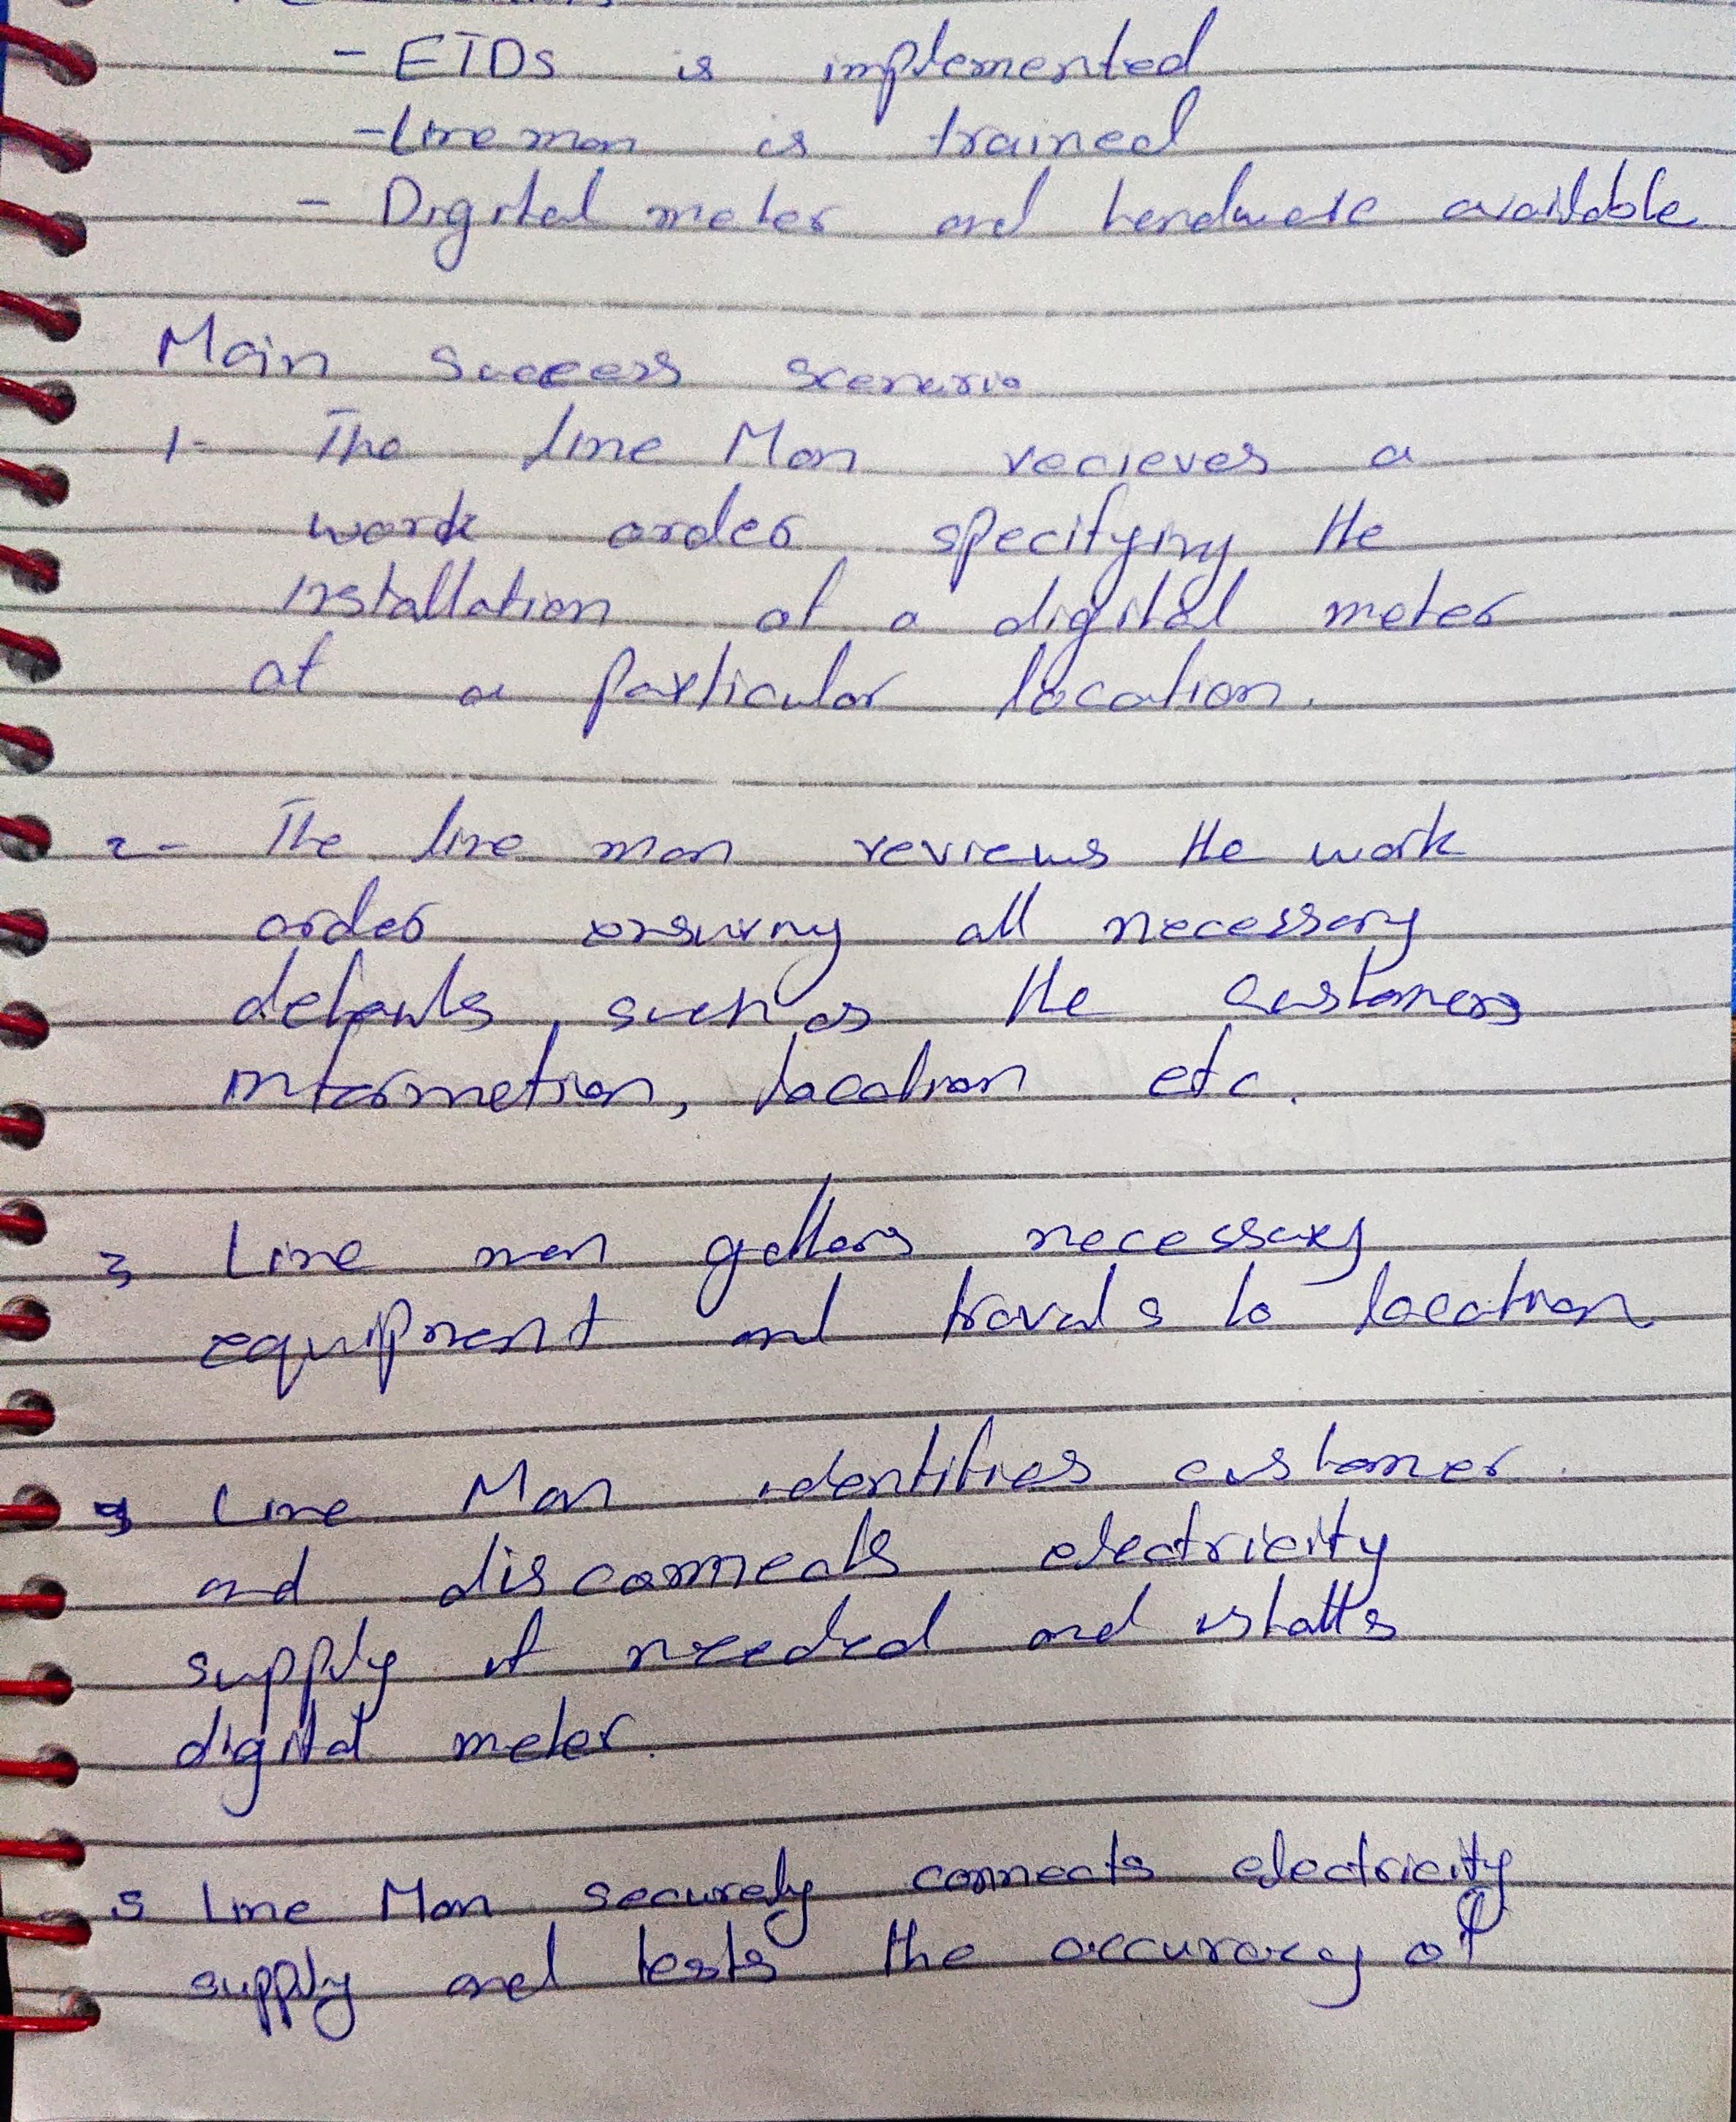

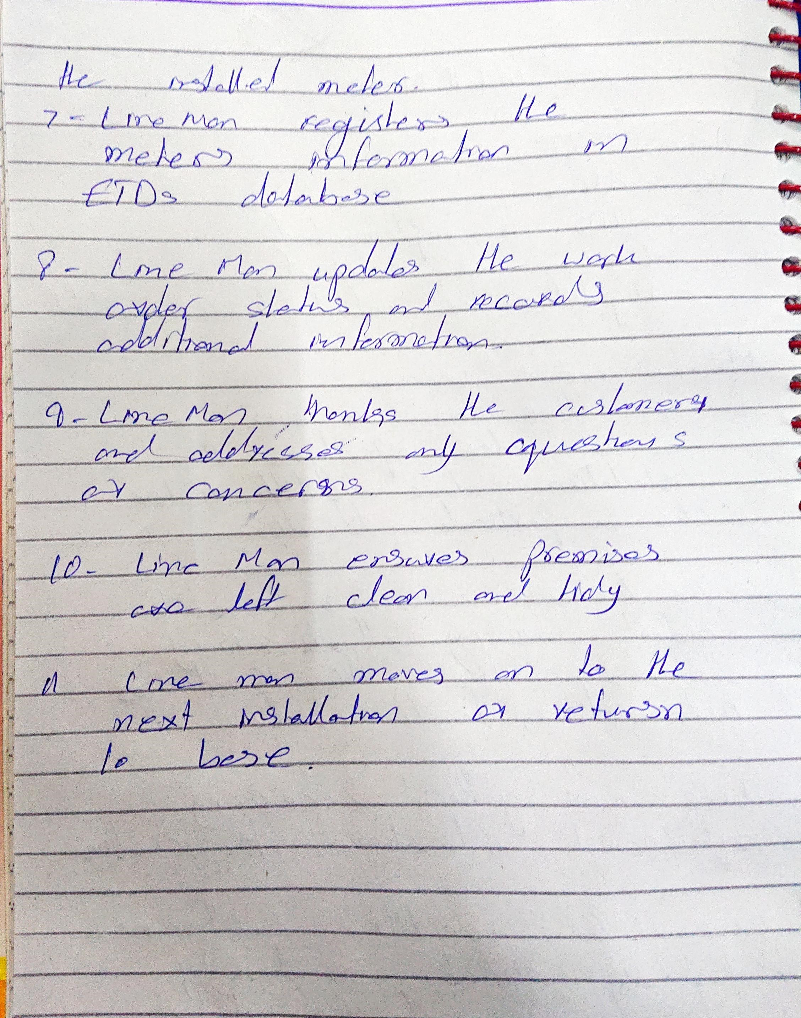

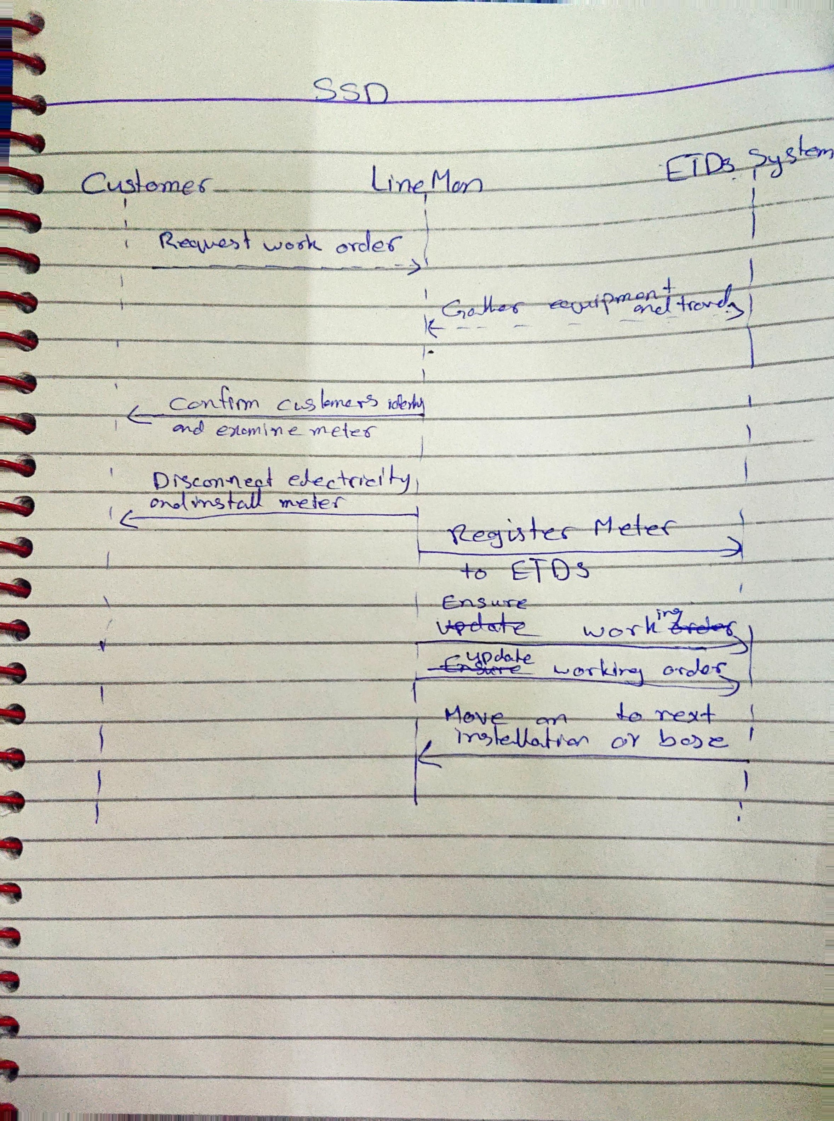

GUI

